外国語理解の能力（読むこと）
プロトタイプC

単元：
BOOK 2, LESSON 7

評価の観点（技能）：
外国語理解の能力（読むこと）

評価規準：
比較級,最上級,同等比較（as～as…），副詞の比較級を含むウェブサイトの記事を読んで，その内容を読み取ることが出来る。

評価方法：
【読み取りテスト】p.84-85 USE Readのテキストと同様の長さ・内容の，比較級，最上級，同等比較(as～as…)，副詞の比較級を含むウェブサイトの記事を読み，その内容についての問いに答えさせ，その出来を評価する。
留意点
USE Read, In-Reading2とパラレルな問題を作成する。

評価基準：A・B・Cの3段階
A：８割以上（10点中，8点以上）が正解
B：５割以上（10点中，5点以上）が正解
C：正解が５割に満たない（４点以下）
（※2点×5問，部分点あり）

評価課題：
次の久美が描いたウェブサイトの記事を読んで，あとの問いに英語で答えなさい。

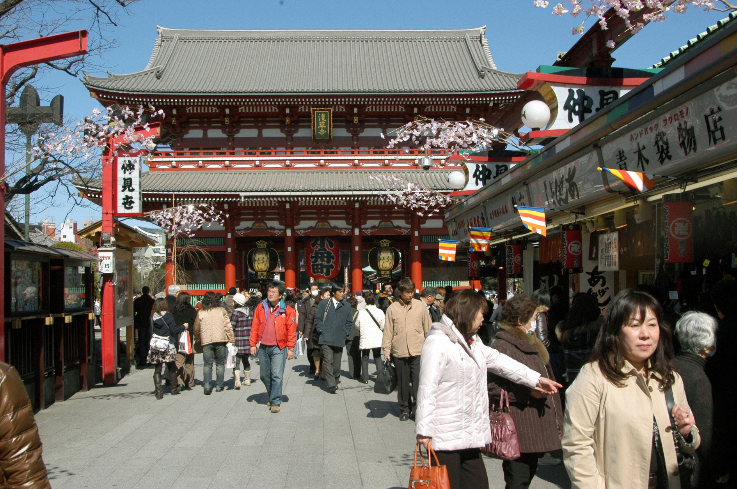
Asakusa
Last week we visited Asakusa for our school trip. We saw some *historical buildings and enjoy shopping at Naka-mise *souvenir shops. There I heard that the number of *tourists for Japan declined. Then we tried to *do a survey about Japan. At Sensoji we asked visitors from foreign countries some questions. “Where are you from?” “What do you want to do in Japan?” “Where do you want to go in Japan?”
Asking foreign people questions in English wasn’t easy. We tried to speak English as much as *possible.
When we came back, we made graphs of their answers. We found that we talked to people from many different countries. Tourists from China were more than those from other countries. Table 1 shows it.

浅草を訪れる人々の出身地・国（Table）

Many tourists came to Japan to see old buildings. Some of them want to ear sushi, sukiyaki, Okonomiyaki and natto. Some Europeans want to go to a hot spring.
日本でやりたいこと（Graph）

Kyoto was the most popular of all. Yokohama was as popular as Osaka. Yokohama was more popular than Hiroshima. *On the other hand, some people wanted to see Tokyo Sky Tree. It is taller than Tokyo Tower. Tokyo Sky Tree was *completed in 2012. It is the tallest building in Japan now.
日本で訪れたい場所（Graph）

I found there were many good places to visit in Japan. I want many people to know about Japan. [231 words]

*historical歴史的な souvenier 土産物 tourist 観光客 do a survey 調査をする possible 可能な on the other hand 一方 complete 完成する

- Where did Kumi visit last week?
- Did Kumi and her classmates ask tourists questions at Sensoji?
- What country did the most tourists come from?
- Was Kyoto more popular than Osaka?
- What is the tallest building in Japan now?

解答例：
- She visited Asakusa.
- Yes, they did.
- They came from China.
- Yes, it was.
- Tokyo Sky Tree is.

